**PLSQL_EXERCISES**

# Exercise 1: Control Structures

## 1. Understanding Control Structures in PL/SQL

PL/SQL (Procedural Language/SQL) supports control structures such as loops, conditional checks, and procedure running. These allow developers to implement logic like updating customer records, applying discounts, or automating reminders.

In a banking system, control structures can be utilized to:

* Process customers based on conditions (e.g., age, balance)
* Apply operations in bulk (e.g., discounts, reminders)
* Automate periodic tasks (e.g., interest application, alerts)

**2. Table Configuration**

Set Up Tables and Insert Sample Data

Customers table

CREATE TABLE Customers (

CustomerID NUMBER PRIMARY KEY,

Name VARCHAR2(100),

Age NUMBER,

Balance NUMBER(10,2),

IsVIP CHAR(1)

);

Loans Table

CREATE TABLE Loans (

LoanID NUMBER PRIMARY KEY,

CustomerID NUMBER,

InterestRate NUMBER(5,2),

DueDate DATE,

FOREIGN KEY (CustomerID) REFERENCES Customers(CustomerID)

);

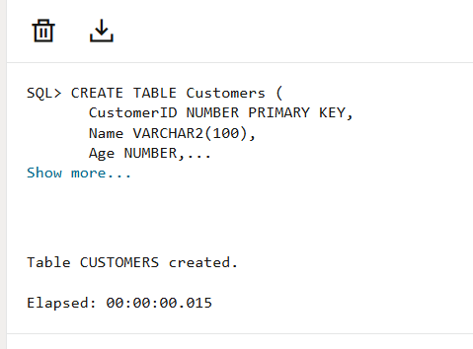 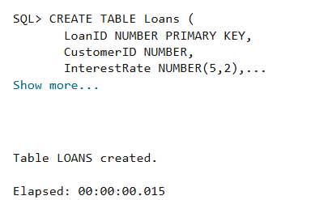

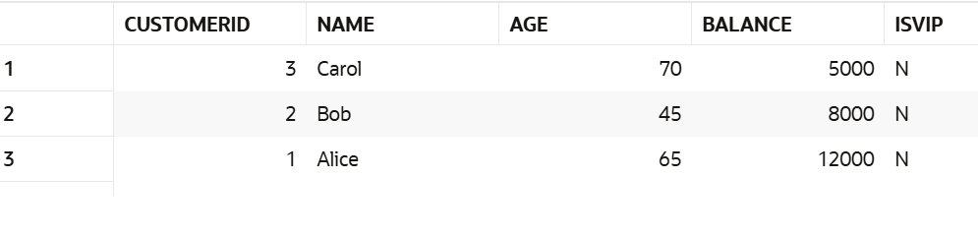

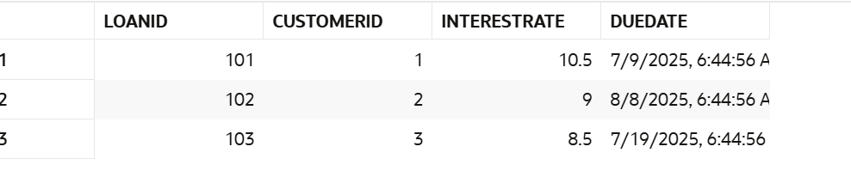

**3.Execution**

**Scenario 1 – Apply 1% Discount for Age > 60**

BEGIN

  FOR cust IN (SELECT CustomerID FROM Customers WHERE Age > 60) LOOP

    UPDATE Loans

    SET InterestRate = InterestRate - 1

    WHERE CustomerID = cust.CustomerID;

  END LOOP;

  COMMIT;

  DBMS_OUTPUT.PUT_LINE('✔ 1% interest discount applied for customers above 60.');

END;

/

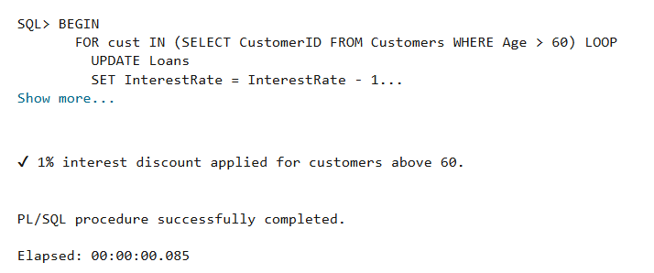

**Scenario 2 – Promote to VIP (Balance > 10000)**

BEGIN

  FOR cust IN (SELECT CustomerID FROM Customers WHERE Balance > 10000) LOOP

    UPDATE Customers

    SET IsVIP = 'Y'

    WHERE CustomerID = cust.CustomerID;

  END LOOP;

  COMMIT;

  DBMS_OUTPUT.PUT_LINE('✔ VIP status granted to eligible customers.');

END;

/

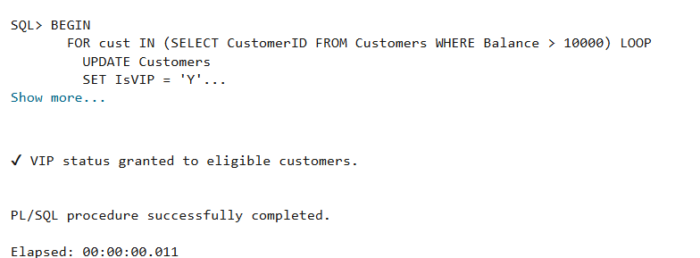

**Scenario 3 – Print Loan Reminders for Next 30 Days**

BEGIN

  FOR loan_rec IN (

    SELECT l.LoanID, l.DueDate, c.Name

    FROM Loans l

    JOIN Customers c ON l.CustomerID = c.CustomerID

    WHERE l.DueDate BETWEEN SYSDATE AND SYSDATE + 30

  ) LOOP

    DBMS_OUTPUT.PUT_LINE('📢 Reminder: Loan ID ' || loan_rec.LoanID ||

                         ' for ' || loan_rec.Name ||

                         ' is due on ' || TO_CHAR(loan_rec.DueDate, 'DD-MON-YYYY'));

  END LOOP;

END;

/

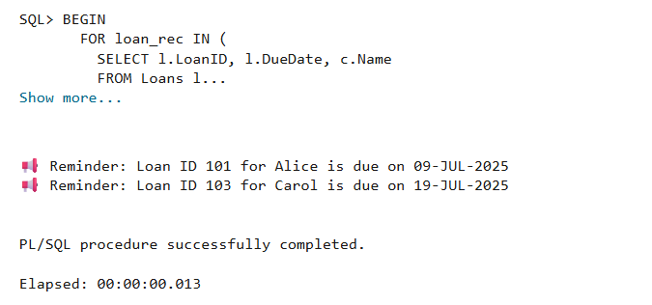

**Final Result:**

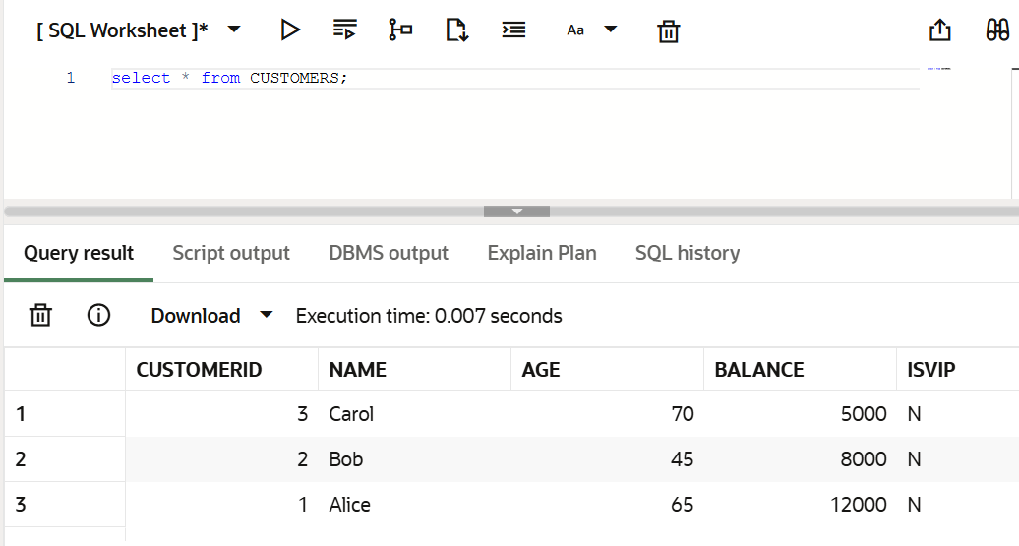

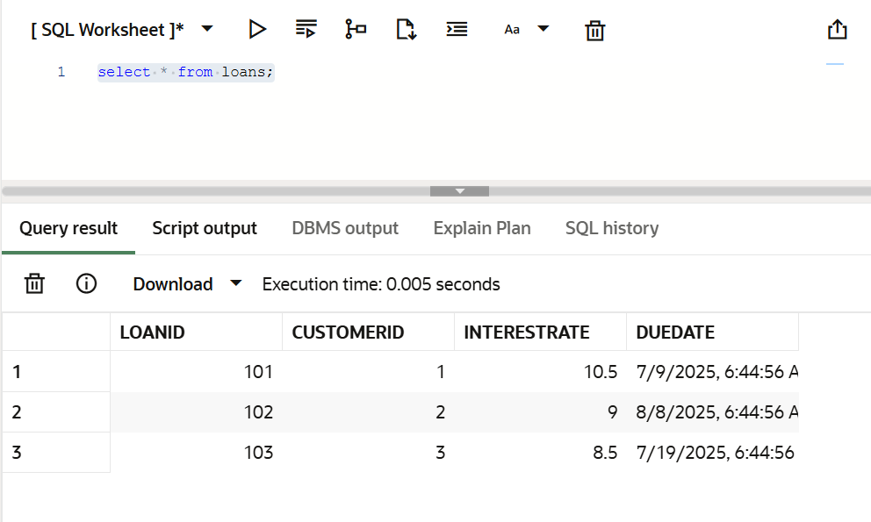

**Exercise 3: Stored Procedures**

## 1. Understanding Stored Procedures in PL/SQL

PL/SQL supports stored procedures, which are named blocks of code that can be saved and reutilized. These procedures allow developers to encapsulate business logic and execute complex tasks in a single call.

In a banking system, stored procedures are extremely utilizeful for:

* Automating repetitive operations (e.g., interest calculation)
* Applying business rules (e.g., performance-based bonutilizes)
* Handling transactional tasks securely (e.g., fund transfers)

They improve code reusability, security, and performance in database-driven applications.

**2. Table Configuration:**

Set Up Tables and Insert Sample Data

Accounts Table

CREATE TABLE Accounts (

AccountID NUMBER PRIMARY KEY,

AccountType VARCHAR2(20),

Balance NUMBER(10, 2)

);

Employees Table

CREATE TABLE Employees (

EmployeeID NUMBER PRIMARY KEY,

DepartmentID NUMBER,

Salary NUMBER(10, 2)

);

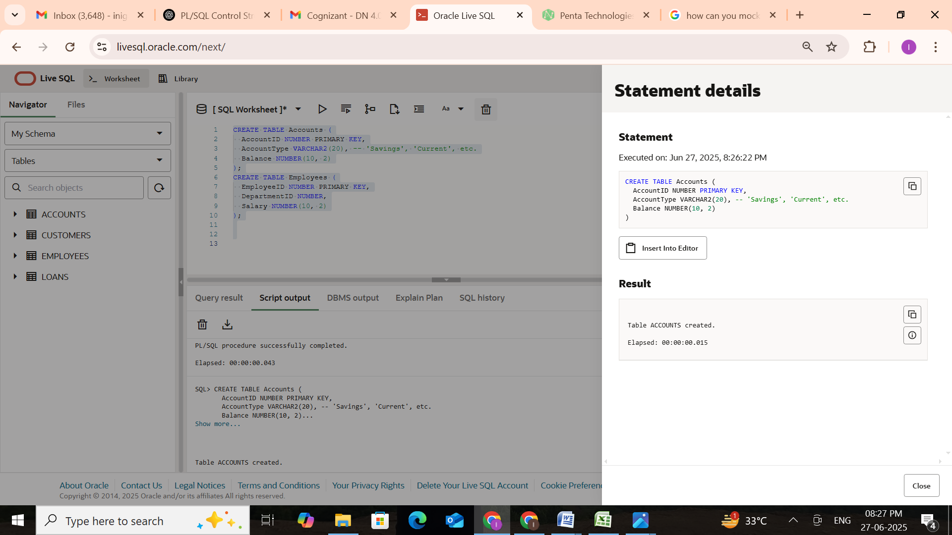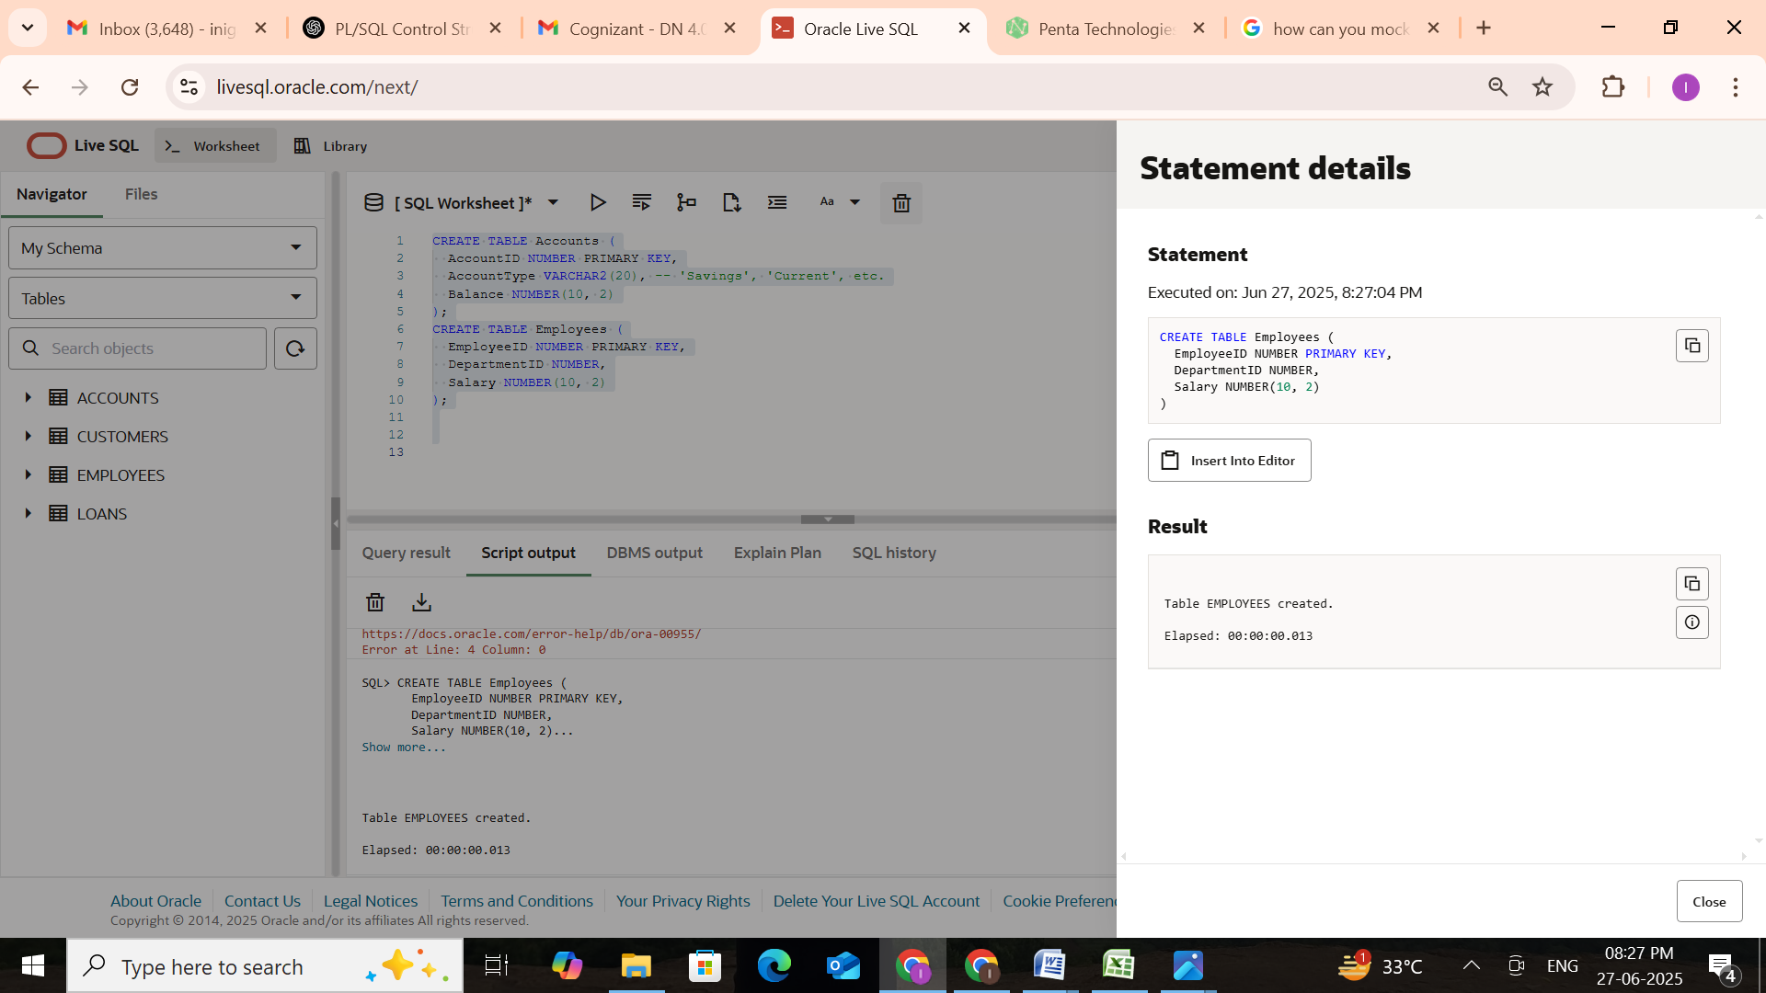

**3. Execution:**

**Scenario 1: Process Monthly Interest for Savings Accounts**

**Step 1: Create Stored Procedure and Apply 1% interest to all savings accounts.**

CREATE OR REPLACE PROCEDURE ProcessMonthlyInterest AS

BEGIN

  UPDATE Accounts

  SET Balance = Balance + (Balance * 0.01)

  WHERE AccountType = 'Savings';

  COMMIT;

END;

/

**Step 2: Execute Procedure**

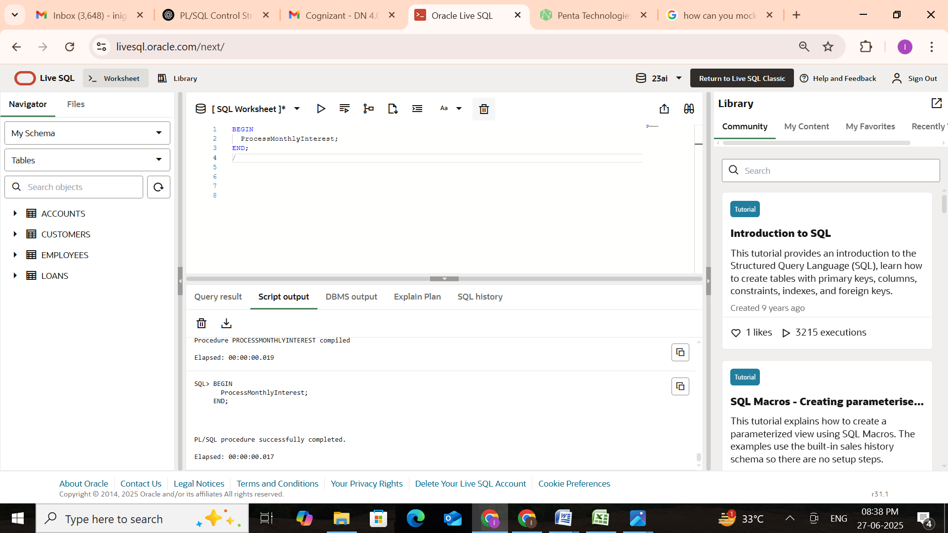

**Step 3: Check Result**

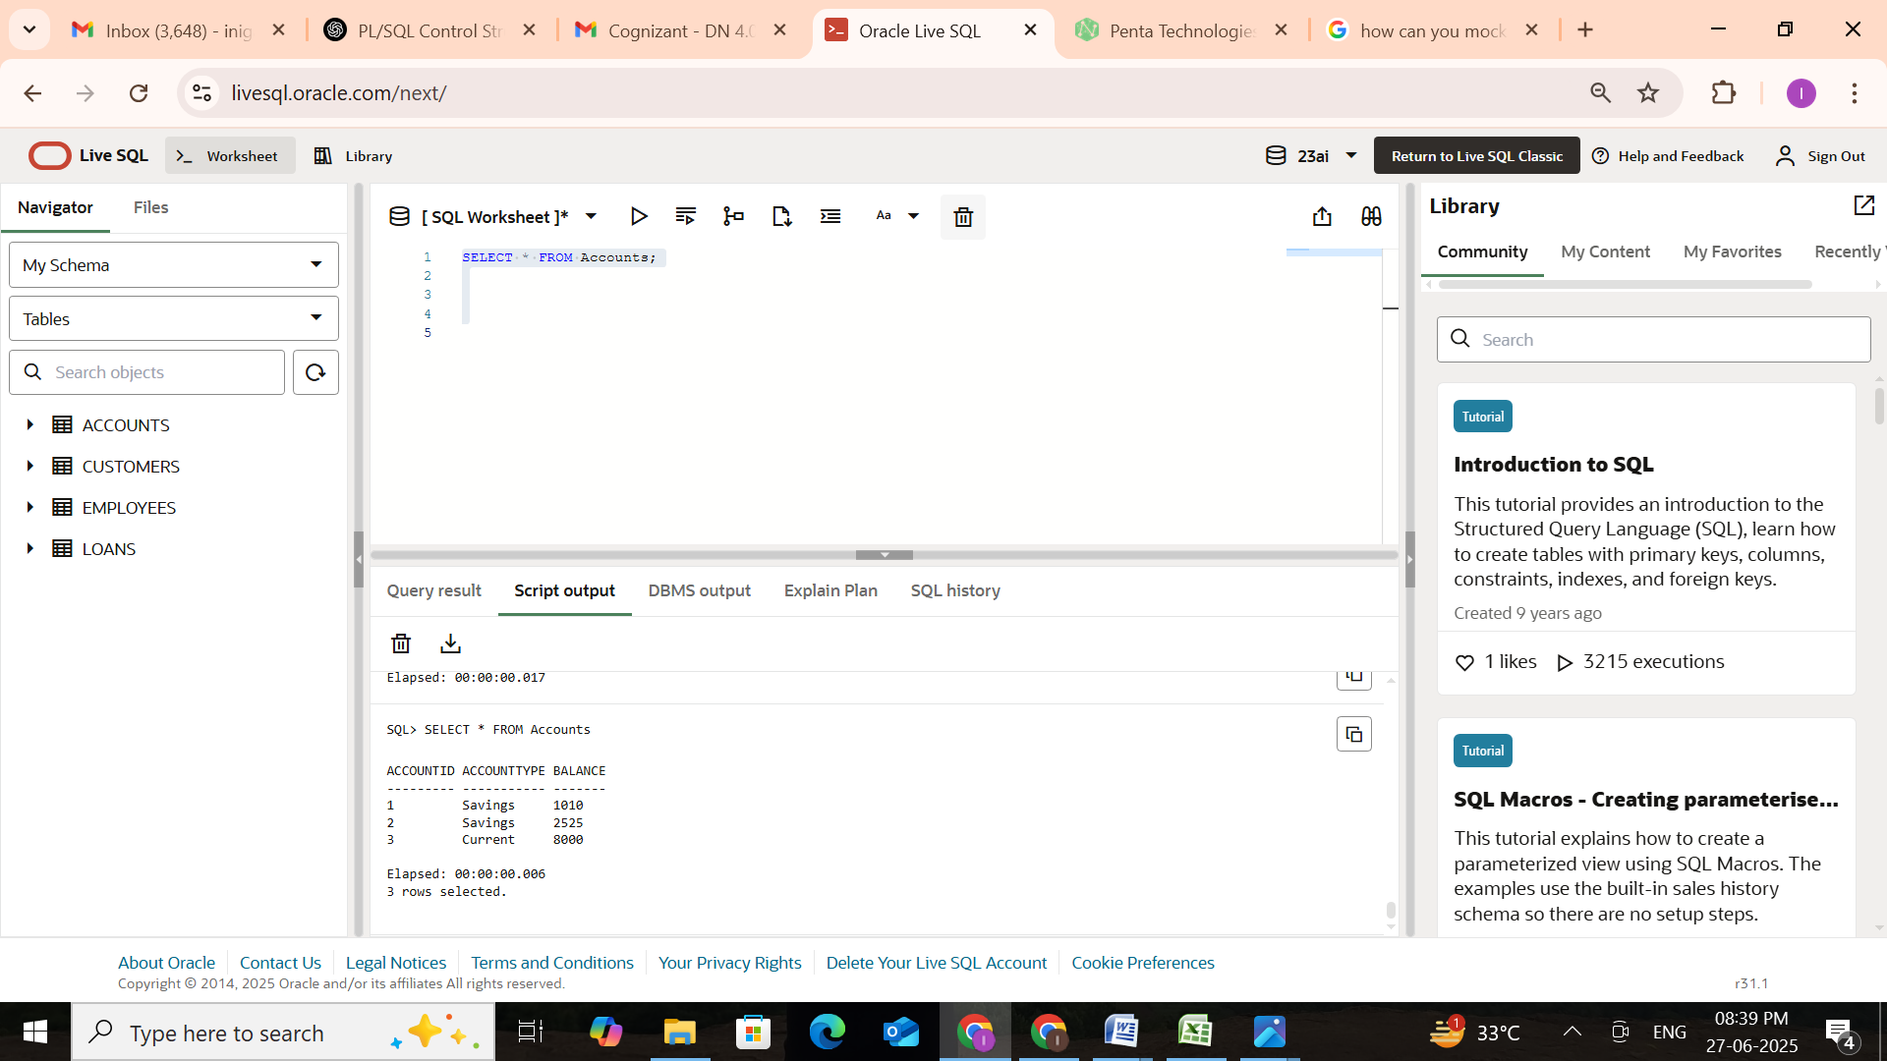

## Scenario 2: Update Employee Bonus by Department

**Step 1: Create Stored Procedure and Update salaries by adding a bonus percentage for a specified department.**

CREATE OR REPLACE PROCEDURE UpdateEmployeeBonus (

  dept_id IN NUMBER,

  bonus_percent IN NUMBER

) AS

BEGIN

  UPDATE Employees

  SET Salary = Salary + (Salary * bonus_percent / 100)

  WHERE DepartmentID = dept_id;

  COMMIT;

END;

/

**Step 2: Execute Procedure (e.g., 10% Bonus for Dept 1)**

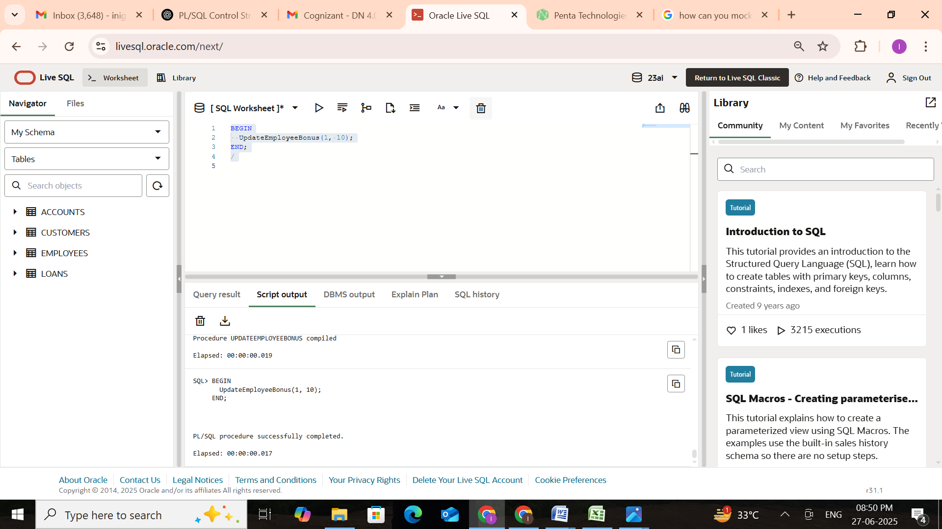

**Step 3: Check Result**

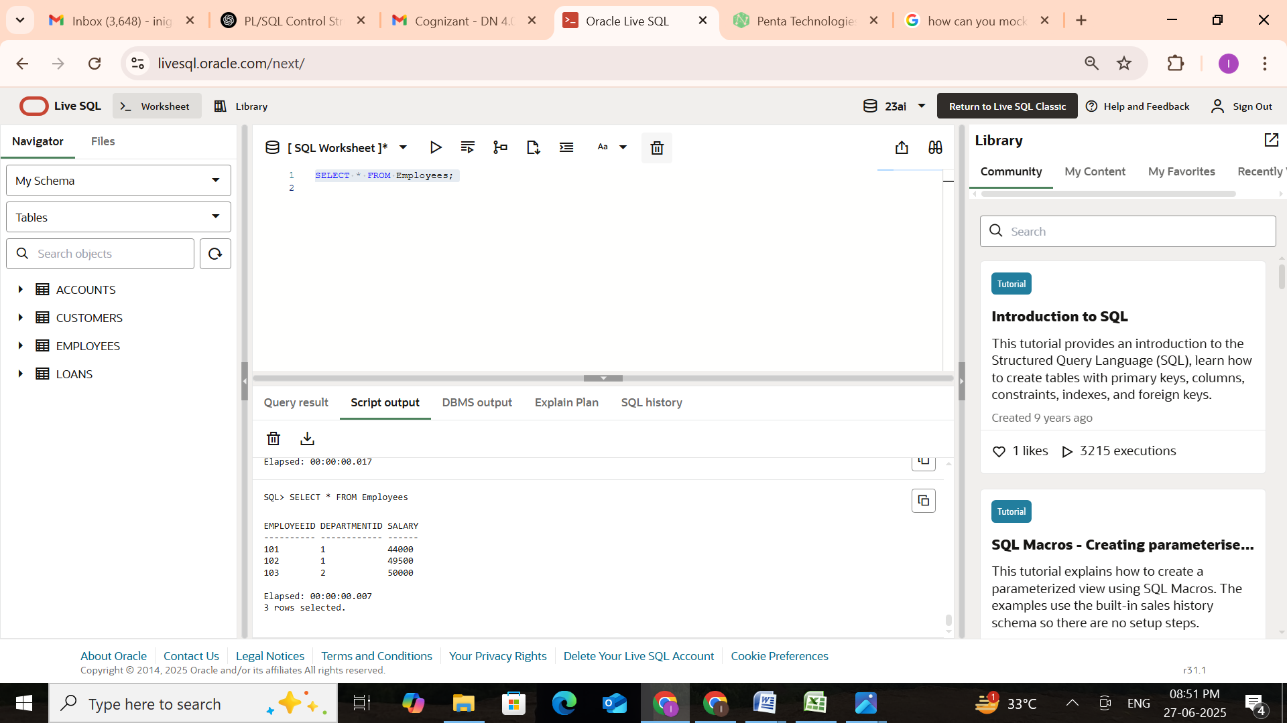

**Scenario 3: Transfer Funds Between Accounts**

Transfer funds between two accounts only if sufficient balance exists in the source account.

**Step 1: Create Stored Procedure**

CREATE OR REPLACE PROCEDURE TransferFunds (

  from_acc IN NUMBER,

  to_acc IN NUMBER,

  amount IN NUMBER

) AS

  insufficient_balance EXCEPTION;

BEGIN

  DECLARE

    current_balance NUMBER;

  BEGIN

    -- Get current balance of source account

    SELECT Balance INTO current_balance FROM Accounts WHERE AccountID = from_acc;

    IF current_balance < amount THEN

      RAISE insufficient_balance;

    END IF;

    -- Debit from source account

    UPDATE Accounts

    SET Balance = Balance - amount

    WHERE AccountID = from_acc;

    -- Credit to target account

    UPDATE Accounts

    SET Balance = Balance + amount

    WHERE AccountID = to_acc;

    COMMIT;

  END;

EXCEPTION

  WHEN insufficient_balance THEN

    ROLLBACK;

    DBMS_OUTPUT.PUT_LINE('❌ Transfer failed: Insufficient balance.');

  WHEN OTHERS THEN

    ROLLBACK;

    DBMS_OUTPUT.PUT_LINE('❌ Unexpected issue occurred during transfer.');

END;

/

**Step 2: Execute Fund Transfer**

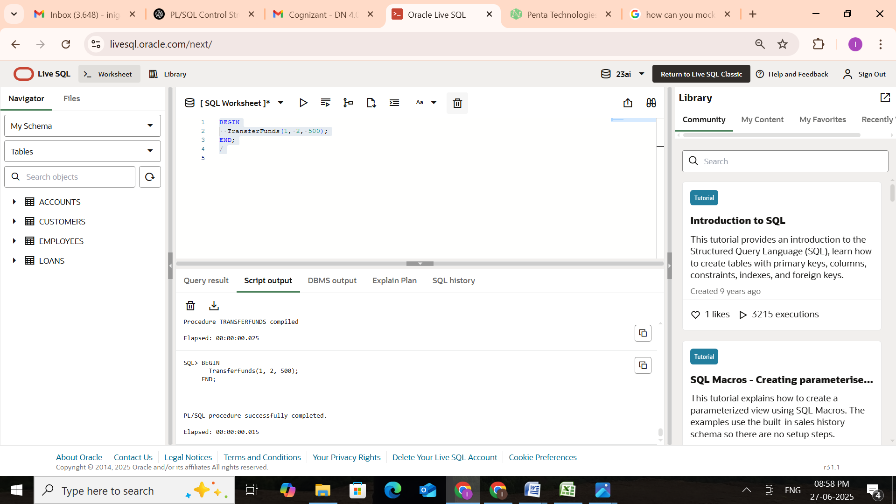

**Step 3: Check Balances**

